# Login

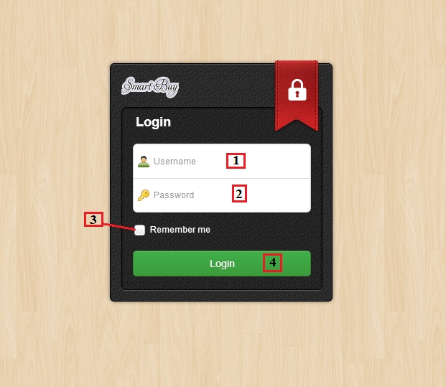

**Figure 01: Admin Login**

|  |  |
| --- | --- |
| **Step** | **Description** |
| 1 | Fill in user’s name |
| 2 | Fill in user’s password |
| 3 | Click button “Remember me” to save user name and password |
| 4 | Click button “Login” to log in the system |

# Import Excel

## Save Product

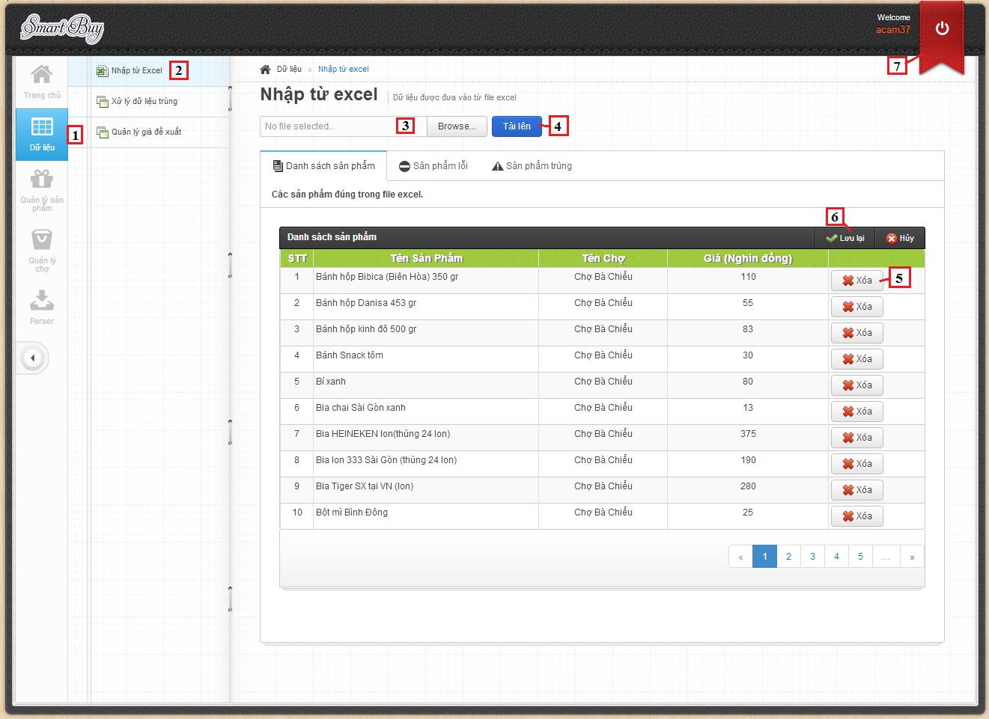

**Figure 02: Import Product**

|  |  |
| --- | --- |
| **Step** | **Description** |
| 1 | Click to button “Dữ Liệu”. |
| 2 | Click to “Nhập từ Excel” link. |
| 3 | Click to select file excel. |
| 4 | Click button “Tải lên” to upload file excel. |
| 5 | Click button “Xóa” to remove product. |
| 6 | Click button “Lưu lại” to save products into database. |
| 7 | Click button “” to Log out the system |

## Handle duplicate product

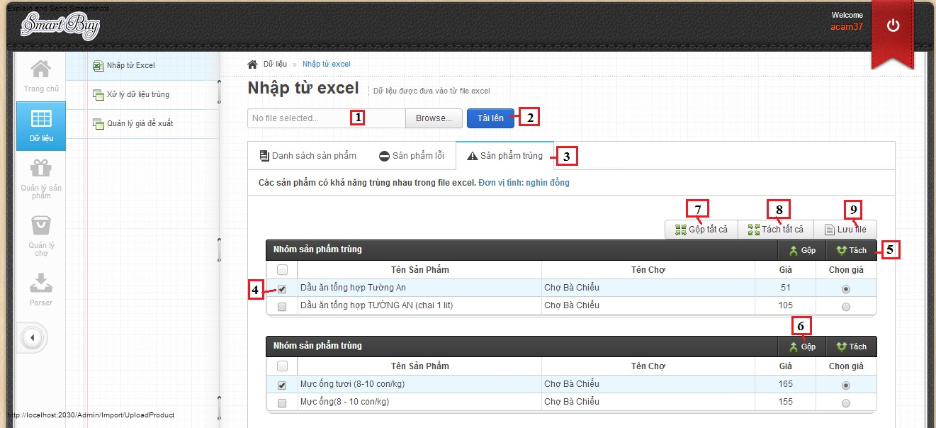

**Figure 03: Handle Duplicate Product**

|  |  |
| --- | --- |
| **Step** | **Description** |
| 1 | Click to select file excel. |
| 2 | Click button “Tải lên” to upload file excel. |
| 3 | Click button “Sản phẩm trùng” tab. |
| 4 | Select product by checkbox. |
| 5 | Click button “Tách” to divide duplicate product. |
| 6 | Click button “Gộp” to join duplicate products. |
| 7 | Click button “Gộp tất cả” to join all duplicate products. |
| 8 | Click button “Tách tất cả” to divide all duplicate product. |
| 9 | Click button “Lưu file” to export duplicate products to text file. |

# Parser

## Create Parser

### View parser

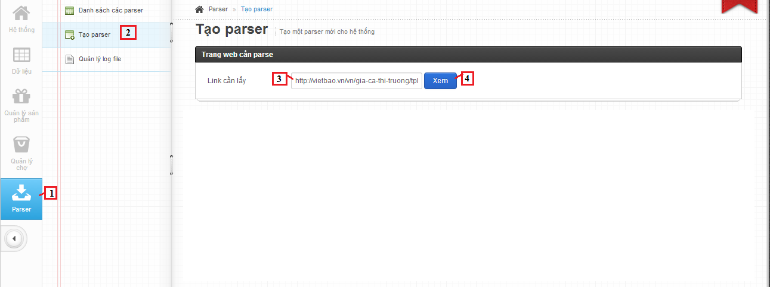

**Figure 04: Create parser – view parser**

|  |  |
| --- | --- |
| **Step** | **Description** |
| 1 | Click tab Parser. |
| 2 | Click link “Tạo parser”. |
| 3 | Fill link to parse. |
| 4 | Click button “Xem” to view website parse. |

### Create parser

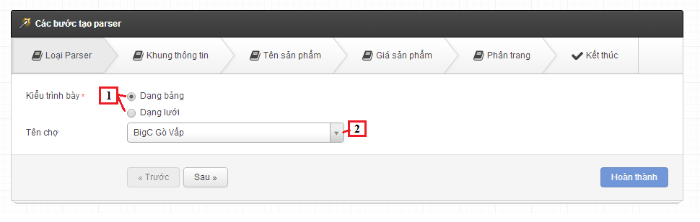

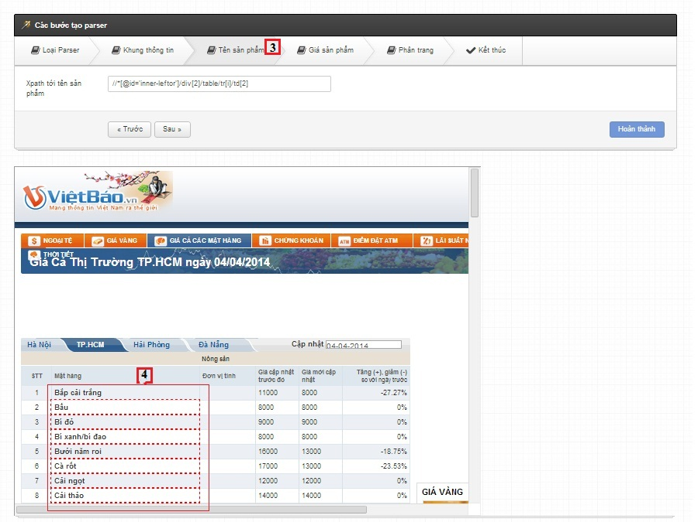

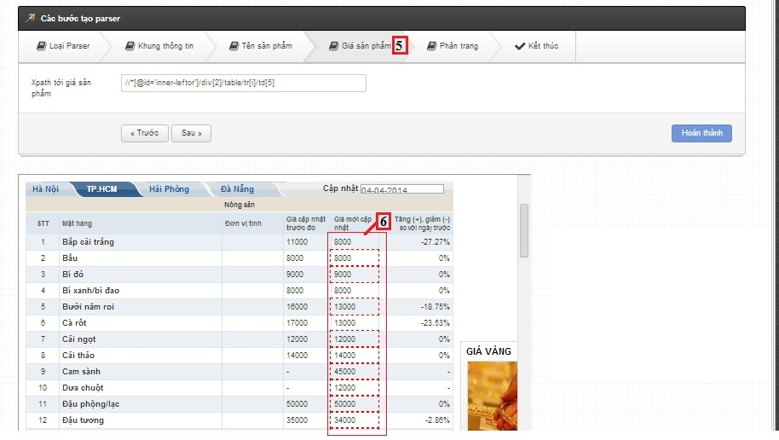

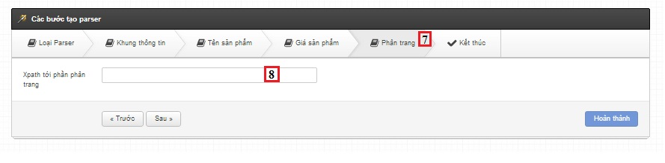

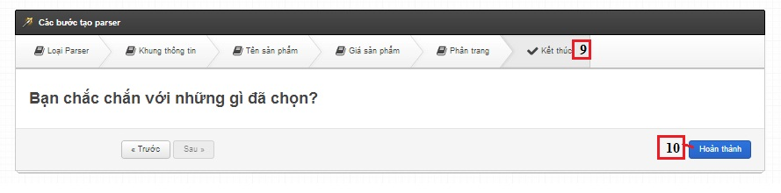

|  |  |
| --- | --- |
| **Step** | **Description** |
| 1 | Choose style of product view |
| 2 | Click to select Market |
| 3 | Click tab “Tên sản phẩm” |
| 4 | Select column product name |
| 5 | Click tab “Giá sản phẩm” |
| 6 | Select column product price |
| 7 | Click tab “Phân trang” |
| 8 | Select paged list |
| 9 | Click tab “Kết thúc” |
| 10 | Click button “Hoàn thành” |

# Configure System

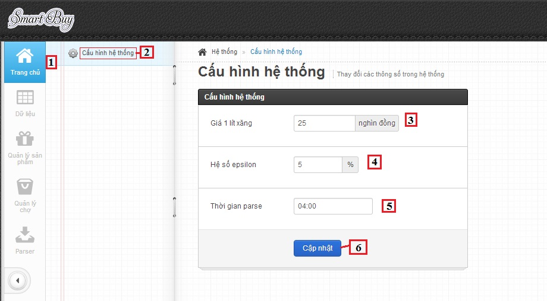

|  |  |
| --- | --- |
| **Step** | **Description** |
| 1 | Click to button “Trang Chủ”. |
| 2 | Click to “Cấu hình hệ thống” link. |
| 3 | Fill price petro |
| 4 | Fill range of price propose |
| 5 | Fill time for parse |
| 6 | Click button “Cập nhật” to save configure system |

# Training

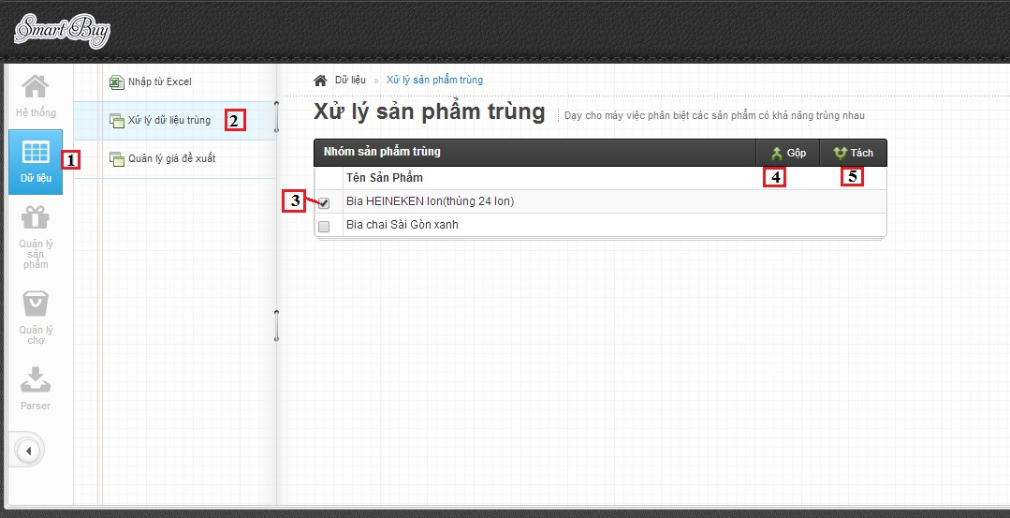

|  |  |
| --- | --- |
| **Step** | **Description** |
| 1 | Click to button “Dữ liệu”. |
| 2 | Click to “Xử lý dữ liệu trùng” link. |
| 3 | Select product by checkbox |
| 4 | Click button “Gộp” for join products |
| 5 | Click button “Tách” for divide products |